Summer Camp Application

Concordia Lutheran School

8701 SW 124th Street
Miami, FL 33176
305-235-0160/FAX 305-235-6168
concordiaschool@bellsouth.net

FOR OFFICE USE ONLY

Class __________ Teacher ____________

Room # ________ Start Date ___/___/___

REGISTRATION & DEPOSIT FEES

ARE NON-REFUNDABLE AND NON-TRASNFERABLE

CHECK ALL THAT APPLY

Session I: ______ Session II: _______ _____ AM Care (7 am to 9 am)
June 19th thru July 14th July 17th thru August 9th _____ EXTENDED Care (4:30 pm to 6:00 pm)

12 – 24 MONTHS: ___ 9:00 am to 1:00 pm (1/2 day) HOT LUNCH: ______ M-F ______ F only
___ 9:00 am to 4:30 pm (full day)

2 YEARS TO 9 YEARS OLDS: ___ 9:00 am to 4:30 pm (full day) Summer VPK (Pre-K only): ___ 8:30 am to 5:00 pm (full day)

Student Information:

Full Name: ______________________________________________________________________________
^{Last} ^{First} ^{Middle} ^{Nickname}
Date of Birth: _____/_____/_____ Sex: Male Female Ethnicity: ________________
Child’s Address: __________________________________ Zip: __________ Phone: (____) ___________
Email Address: _____________________________________________________________

Family Information: Child lives with: _______________________
Mother’s Name: ____________________________ Father’s Name: ____________________________
Address: ___________________________________ Address: ___________________________________
Phone: (____) ________ Bpr/Cell: ____________ Phone: (____) ________ Bpr/Cell: __________
Employer: _________________________________ Employer: _______________________________
Address: ___________________________________ Address: _________________________________
Work Phone: (_____) _________________________ Work Phone: (____) ________________________

Medical Information:
I hereby grant permission for the staff of this facility to contact the following medical personnel to obtain emergency medical care if required.

Doctor: _____________________ Address: _________________________ Phone: (____) ________
Dentist: _____________________ Address: _________________________ Phone: (____) ________
Hospital Preference: ____________________________________________ Phone: (____) ________

Please list all allergies, special medical or dietary needs or other areas of concern:
_________________________________________________________________________________________
_________________________________________________________________________________________

About Concordia:
Would you like to know more about our church? Yes No Is the child baptized? Yes No
Your home church: ________________________________ Child’s religion: ______________

Referral Information:
How did you find out about Concordia? Website? Ad? Sign? Referred by: ________________

Contacts:
The child will be released only to the custodial parent or legal guardian and the persons listed below. The individuals listed below are also authorized to sign‐in and sign‐out on the Early Learning Coalition of Miami‐Dade and Monroe’s Parental Signature Sheet & Attendance Verification Form for my child. The following people will also be contacted and are authorized to remove the child from the facility in case of illness, accident or emergency, if for some reason the custodial parent or legal guardian cannot be reached:
___________________________________________________________________________________________^{Name} ^{Relation} ^{Work #} ^{Home #}

___________________________________________________________________________________________ ^{Name} ^{Relation} ^{Work #} ^{Home #}

___________________________________________________________________________________________ ^{Name} ^{Relation} ^{Work #} ^{Home #}

___________________________________________________________________________________________ ^{Name} ^{Relation} ^{Work #} ^{Home #}

Name and phone number of the first person to be called in case of an emergency:
___________________________________________________________________________________________

Custody:
Who has custody of the child? _____ Mother _____ Father _____ Other ______________________
^{Name/Relation}
Helpful Information About the Child:

Section 65C-22.006(2), F.A.C., requires a current physical examination (form3040) and immunization record (Form 680 or 681) be available on the first day of attendance.

Section 402.3125(5), F.S., requires that parents receive a copy of the Child Care Facility Brochure, KNOW YOUR CHILD CARE CENTER.

Section 65C-22.006(4)c 2., F.A.C., requires that parents are notified in writing of the disciplinary practices used by the child care facility.

By signing below, you verify that you have received the above items and that all information on this enrollment form is complete and accurate.

__________________________________________
Print Name-Parent/Guardian

__________________________________________ _______________________
Signature of Parent/Guardian Date

Billing Preferences

Child’s Name: ______________________________________________
Parent Name: ______________________________________________

Please select your choice:
A. How would you like to receive your invoice?
1. By e-mail _________ Your e-mail ______________________________
2. In the school mail box _________

- Would you like to receive a receipt?
1. Yes _______
2. No _______

- Do you need an invoice showing payments and charges for your flexible spending account?
1. Yes _______
2. No _______

- Would you like to sign up for savings, checking or credit card automatic payment?
1. Yes _______ (if yes please complete attached enrollment form)
2. No _______

Savings, checking or Credit Card Automatic Payment Authorization Form

I hereby authorize
_________________________________________
(Print name of your financial institution)

to make my automatic payment on my behalf from the savings, checking or credit card account listed below and transfer it to Concordia Lutheran School.

CHOOSE ONE:
____ Checking Account Transfer
(Voided check must be attached.)

____ Savings Account Transfer
________________________________
(Savings Account Number)

____ Credit Card Charge
___ Visa ___ American Express
___ MasterCard ___ Discover
____________________________________
(Credit Card Number)

___________/__________ (month/year)
(Expiration date)

I understand that I am in full control of my payment, and if at any time I decide to make any changes or discontinue this service, I will notify Concordia Lutheran School. Change of payment method will not affect the terms of my contract.

Name ____________________________________
Address __________________________________
City _____________________________________
State ___________________ Zip ______________

Signature _________________________________

Date _____________________________________

Credit Card On File

I, _________________________________ authorize Concordia Lutheran School to charge my credit card listed below for any invoice of services provided for my child/children which has not been paid within 30 days of due date. Should I have any problems with my bill I will notify the school in writing prior to the due date. I have provided my credit card billing information voluntarily and acknowledge full financial responsibility for all charges incurred as a result of services provided to us. Please charge the credit card listed below.

CHOOSE ONE:

____ Credit Card Charge

___ Visa ___ American Express ___ MasterCard ___ Discover

____________________________________
(Credit Card Number)

___________/__________ (month/year)
(Expiration date)

Name _________________________________________________________________________
Address _______________________________________________________________________
City __________________________________________________________________________
State ______________________________ Zip _____________________

Signature _____________________________________ Date ____________________________

Photography / Video / Shutterfly Permission

Concordia Lutheran School, Concordia PTA and Concordia Lutheran Church takes photographs and videos of children enrolled at its center on a regular basis for business purposes. Concordia Lutheran School, PTA, and Church retains all rights, title, and interest in these materials and may use and disseminate them in the class Shutterfly accounts. Concordia Lutheran School, PTA, and Church takes care that any use, display, or dissemination of photographs or videos of children, whether at a particular center where the child attends or for its general business purpose, is accomplished in a thoughtful, safe, and secure manner appropriate under the particular circumstances. For example, at Concordia, these materials may be used to better communicate with families and to illustrate the daily curriculum, to chronicle a child’s development, or document center activities. These photos may be shared with you and other families on a secure Shutterfly account, Concordia website, Concordia Lutheran Church and School Facebook, private PTA Facebook page and posted in the center.
Concordia School and each class will be putting together a Shutterfly email list. (It will only include child’s name, parent/guardian’s name and email address.) We would like all of the families to participate.
- I give permission to Concordia Lutheran School and Church to take photographs and video of my child during his/her enrollment and to use these materials for its business purpose.
- I do not give permission to Concordia Lutheran School to take photographs and video of my child during his/her enrollment and to use these materials for its business purpose.
- Concordia Lutheran School and class does not have permission to include my child’s information in the Shutterfly directory. I realize that if I choose this option, then my child’s name will not appear on the class list.

Child Name:________________________________________________________
Parent/Guardians Name:______________________________________________
Parent/Guardian E-mail Address: _______________________________________
__________________________________________________________________

Signature:________________________________________ Date:_____________
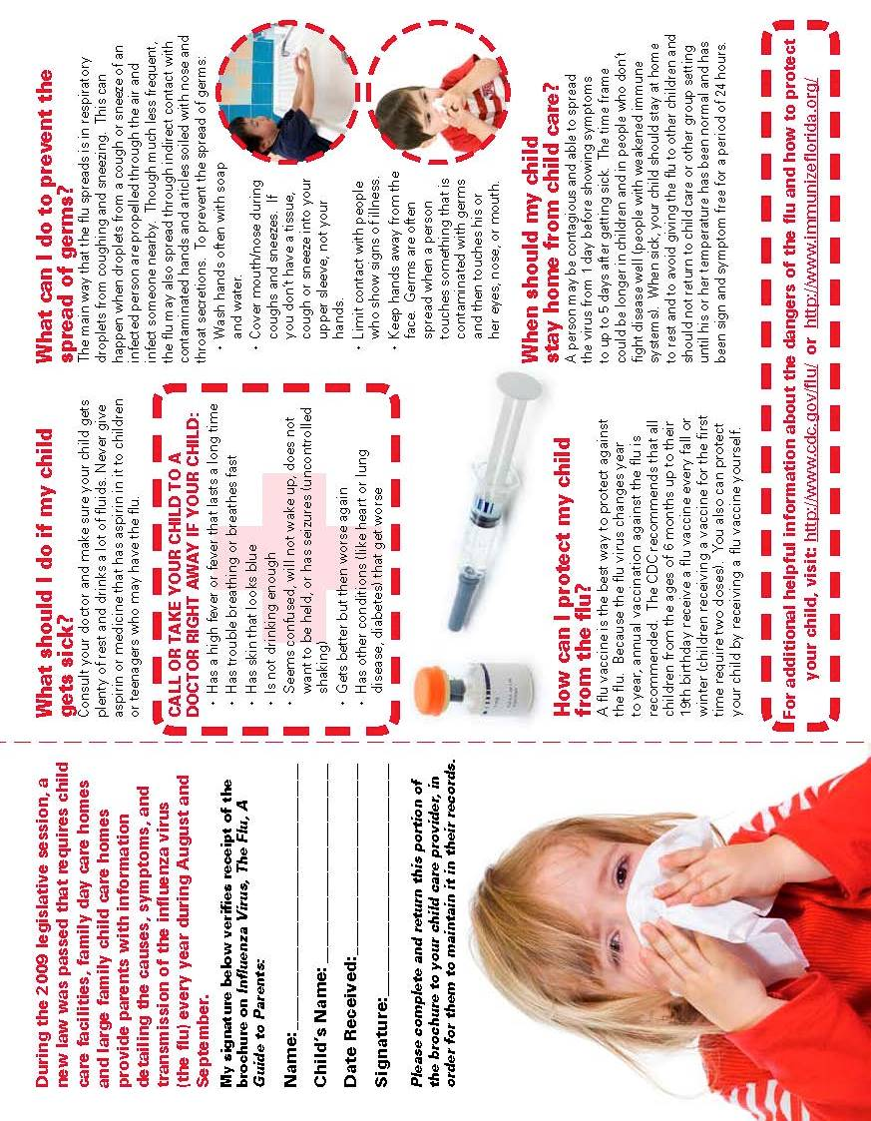
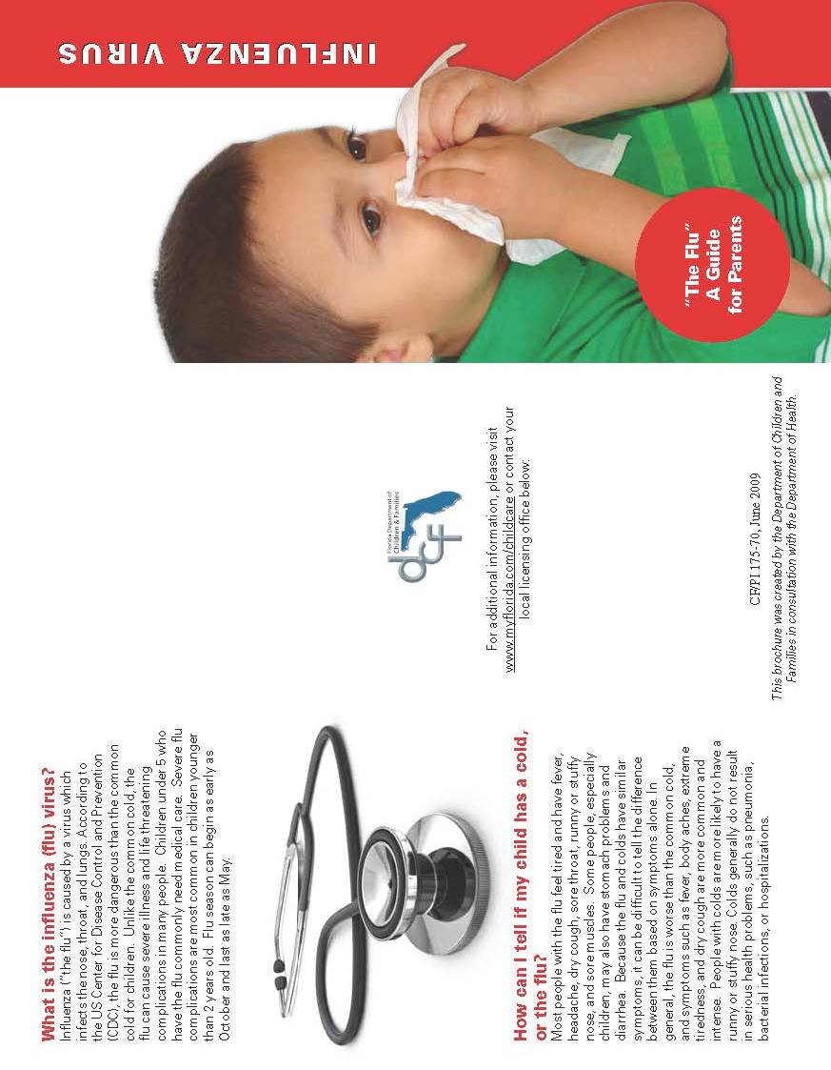
Parent Release-Sunscreen and Insect Repellent

Sunscreen and insect repellent should be applied to a child at least once at home to test for any allergic reaction. Aerosol sprays and combined sunscreen and insect repellent are prohibited.

Sunscreen/sunblock: must provide UVB and UVA protection with an SPF of 15 or higher.
Insect repellent: may not be used if recommended by public health authorities or requested by a parent/guardian. The repellent may not contain a concentrate of more than 30% DEET, DEET free is preferred. Repellent may be applied no more than once a day.

All sunscreen/sunblock and insect repellent provided by a parent/guardian must be:
- Provided in the original containers;
- Clearly labeled with child’s full name;
- Within the expiration date; and
- Appropriate for the age of the child.

I give Concordia Lutheran School permission to apply (name of sunscreen) _____________________________
and/or (name of insect repellent) ______________________________________________________________
to my child (a separate form is required for each child), _________________________________
From: _____/_____/_____ To: _____/_____/______ (not to exceed one year)
Special Instructions
Sunscreen/Sunblock: __________________________________________________________________________________________
__________________________________________________________________________________________

Insect Repellent: ____________________________________________________________________________________________________________________________________________________________________________________

___________________________________ _____________________________
(Parent/Guardian Signature) (Date)

Print Name: ____________________________________________________________

Authorization For Emergency Treatment

Permission to the Director, Acting Director, or the teacher to take whatever steps may be necessary for medical care of an emergency is hereby given, I understand that the order of actions taken will follow the outline below unless there is a need for immediate action, but will not be limited to these action

- Parent or Guardian will be called.
- Child’s Physician will be called.
- Contact person will be called (those that parents have listed).
- If none of these efforts are successful:
- Another physician will be called.
- An ambulance will be called.
- Authorize Concordia Lutheran School to transport my child to:
______Baptist Hospital (Children’s ER)________
- In order for the school to assume responsibility for my child. I understand that I must sign the child in and out at departure time.

Child’s Physician Name: ___________________________________________________________________
Address: _______________________________________________________________________________
Phone Number: _________________________________________________________________________
Chronic Health Conditions: ________________________________________________________________
Health Insurance Coverage: ________________________________________________________________

Signed: _________________________________ Date: ___________________________
Parent/ Guardian

In signing this page, you are giving us authority to call rescue even in the event that we cannot get in contact with either parent or the persons listed by the parents.

